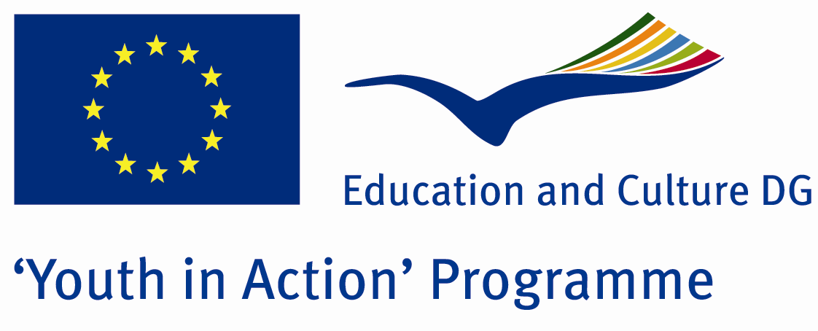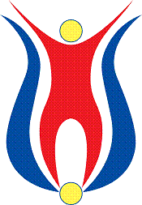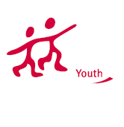

Action 1.1
Project Summary;
We decided to do this Project because of the Project we have done last summer. That Project seemed to us, Europen culture is a culture mosaic of nested. Even miles and miles range of countries, europen countries are a whole. They live same events, they smile same things, they cry same things and etc. So we thought that europe is a country all.

Project Title; Universal Life
Date and Venue ; 28.01.2012-04.02.2012 Turkey
Place: Edirne

Target Group ; Municipalities, City Councils and Non-Governmental organizations,
youth groups,culture and art groups,e.t.c

Participants ; 5 people from each country (over 18 -25 ). Totally 8 countries.

Conditions ; Accommodation, board and programme costs will be financed through European Commission Youth in Action Programme . Travel costs will be reimbursed in 70% (APEX Tarrifs). Organizations from all 27 EU member countries plus Liechtenstein , Norway and Iceland are eligible to take part.

Working language: English

Organisator group:Group Edirne

How to apply: If you are interested, please send your Part III forms to
by e-mail please (in word file). Scan Part3 format is enough for application.(Fulfilled Part III which you can find in the attachment, of course signed and stamped) ..

Contact e-mail: groupedirne@gmail.com

